
a
Company
Logotype

Cone Beam Computed Tomography- Report



Porur Dental X-rays & CBCT

Patient Name : Mrs. Salomie | Date of Report : 25.10.2024
Age/ Gender : 72 years/ Female | Region of Interest : CBCT Maxilla
Referring doctor: Dr. Thilagadevi | Indication : Implant assessment
Clinical Notes: Nil
PATIENT INFORMATION

CBCT- Maxilla provided
CBCT – IMAGE DETAILS

RADIOGRAPHIC INTERPRETATION

- Completely missing crown and root portion in relation to 16, 17, 18, 26, 27, 28.
- Root stumps: 15
- The maxillary alveolar ridge is present with degenerative changes causing reduced height of alveolar ridge, however the existing bone is present with normal trabecular pattern.
- The teeth 23, 25 are present with hyperdense restorative material within the root canals upto the apical third. Hyperdense crown structures evident in relation to 14, 23, 24, 25.

IMPLANT ASSESSMENT

 | 15 region | 16 region | 17 region | 25 region | 26 region | 27 region
Sub-Crestal  (in mm) | 7.72 | - | - | - | 10.88 | 9.37
Mid- Crestal  (in mm) | 7.8 | - | - | - | - | -
Distance between the alveolar ridge and floor of the maxillary sinus (in mm) | 6.89 | 2.37 | 2.37 | 2.72 | 5.77 | 7.65

RADIOGRAPHIC IMPRESSION

- Partially edentulous maxillary arch.
- Root stumps: 15
- Crown in relation to 14, 23, 24, 25.

Kindly correlate with clinical findings


IMAGES FOR REFERENCE

RECONSTRUCTED PANORAMIC VIEW

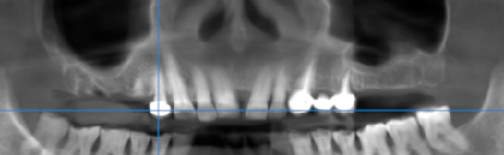

3-DIMENSIONAL VIEW

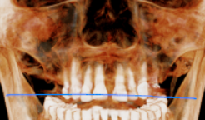

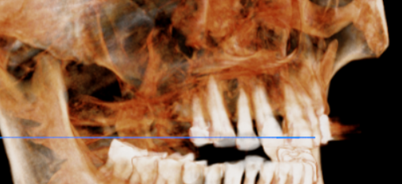
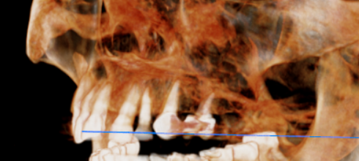

CROSS SECTIONAL VIEW

15 region | 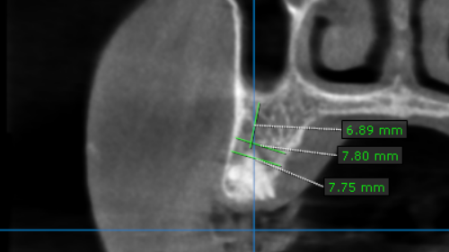
16 region | 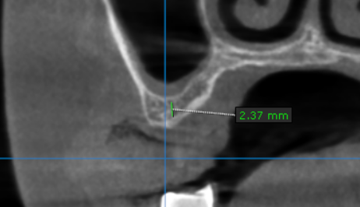
17 region | 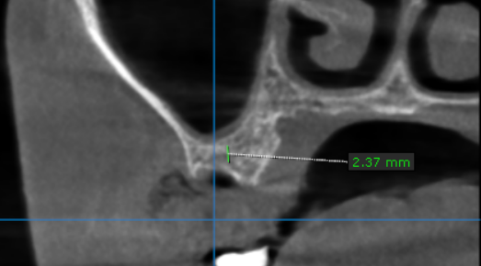
25 region | 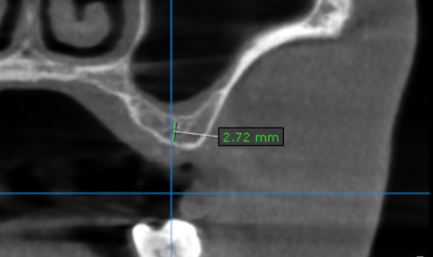
26 region | 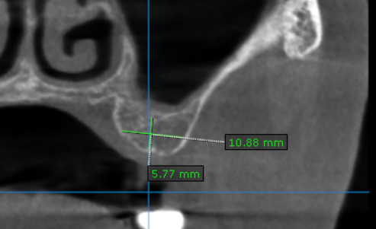
27 region | 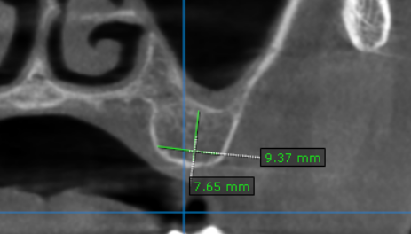

**** End of report ****

